  **Department of Computer Science and Engineering**

**Company Profile**

**Course Code : CSE236**

**Course Tittle : Software Project II**

**Semester : Fall-2023**

Submitted To Submitted By

Md. Golam Rabbany Anukul Chandra

Lecturer, Dept. of CSE ID: 221-15-5585

Daffodil International University. Section: 61_U

Submission Date: 08 November, 2023

Prof. Md .Lutfur rah

Vice-Chancelor

Daffodil International Universty

Savar ,Ashulia

Dear Sir,

I hope this letter finds you in good health and high spirits. I am writing to formally request your consideration in establishing a mutually beneficial agreement between our organization and Daffodil International University implement a project “Attendence Management system ”. This collaboration aims to enhance time savings, cost savings, easiest way to handling Students data and Students attendance .

Here is my System Requirement Specification for my proposed “Student Attendence System”. I kindly request to read my specification and a meeting at your earliest convenience to discuss the details of this proposed agreement.

We are excited about the potential collaboration between our organizations and the positive impact it could have on both our customers and the community at large.

Thank you for considering our proposal. We eagerly await the opportunity to engage in a productive discussion with you regarding this potential partnership.

Yours sincerely,

Anukul Chandra

Senior. Software Developer

United Software company

Contact us

Email: [anukulchandra4949@gmail.com](mailto:anukulchandra4949@gmail.com)

Cell: 01957541387

**Software Requirements**

**Specification(SRS)**

Of

**Attendance Management System**

Version 1.0

Table of Contents

Introduction 8

1.1 Purpose 8

1.2 Scope 8

1.3 Definitions, Acronyms, and Abbreviations 8

1.4 Overview 9

2.1 Product Perspective 10

2.2 Product Functions 10

2.3 User Characteristics 10

2.4 Assumptions and Dependencies 11

Specific Requirements 12

3.1 External Interface Requirements 12

3.1.1User Interfaces 12

3.1.2Hardware Interfaces 12

3.1.3Software Interfaces 12

3.1.4Communications Interfaces 12

3.2 Functional Requirements 12

3.2.1Student Registration: 12

3.2.2Student Attendance Management: 13

3.2.3Opinion Management: 13

Use Cases 13

Classes / Objects 14

Non-Functional Requirements 15

3.2.4Performance 15

3.2.5Reliability 15

3.2.6Availability 15

3.2.7Security 16

3.2.8Maintainability 16

3.2.9Portability 16

3.3 Design Constraints 16

Other Requirements 16

Project Timeline 17

Pricing and Payment 17

Installation System 17

Software Development Life Cycle (SDLC) Model : 18

6.2 RAD Model : 18

6.3 Spiral Model : 18

6.5 Incremental Model : 19

6.7 Agile Model : 19

6.8 Iterative Model : 19

6.9 Big Bang Model : 20

SDLC Model for this Project: Agile Methodology : 20

Analysis Models 22

Data Flow Diagram ( DFD ) 23

State-Transition Diagrams (STD) 24

Appendices 25

Appendix : Glossary 25

# Introduction

Student management system has become important factors in modern education field. This system should help the institutional to streamline the administrative task and provide real-time access to the data. Building this system in web based interface will further help the ease of accessibility through any web browser. The study findings enable the definition of the project problem statement, its objectives, scopes and advantages of the student management system.

## Purpose

The purpose this documents is to present a detailed description of the Student Management System. It will explain the purpose and features of the software, the interfaces of the software, what the software will do, the constraints under which it must operates and how the software will react to external stimuli. This document is intended for both the end users and the developers of the software.

## Scope

This document covers the requirements for the Student Management System. This software will provide a graphical environment in which the users of the system will be able to perform various operations that are associated with storing, marinating, updating and retrieving Student information. The purpose of this is to guide developers in selecting a design that will be able to accommodate the full-scale application.The system will capture information about student’s personal details lectures and the courses**.** Storing updating and retrieving in a fast and accurate way.

## Definitions, Acronyms, and Abbreviations

The Student Management System has to handle records for many number of students and maintenance was difficult. Though it has used an information system, it was totally manual. Hence there is a need to upgrade the system with a computer based information.

## Overview

The purpose this documents is to present a detailed description of the Student Management System. It will explain the purpose and features of the software, the interfaces of the software, what the software will do, the constraints under which it must operates and how the software will react to external stimuli. This document is intended for both the end users and the developers of the softwar

## Product Perspective

**General Description**

The product Student Management system, is an independent product and does not depend on any other product or system. The product will automate various tasks associated with handling student details and better organizing the stored information and optimum performance, thus helping the Colleges to ensure smooth working of these processes.

## Product Functions

Our system has two types of accessing modes,

* + 1. Administrator
    2. User
    3. Teacher
    4. Student

1. **Administrator:**

SMS is managed by Administrator. Administrator has to update and monitor the registered student details, add a new student, provide register number for all students, assign each student a course etc., Administrator can update his profile, and also can give help to the teachers and students.

1. **User:**

There are two users:

* 1. **Student**:

User can only view their personal details, course assigned, and edit their assigned course and can view their attendance.

* 1. **Teache**r:

User can add them onto the portal and view their schedules, marks attendance of the students, also can view the students details in graphical order, also of a single student and about the views from the students.

## User Characteristics

This software gives access to two kinds of users.

* + 1. **Administrator**: The personnel and College administrator will have administrator access to add, delete and modify information stored in the database.
    2. **Authorized User**: Teaching staff will have access to only view the data stored in the database and can update the student’s attendance in the form of formatted reports.

## Assumptions and Dependencies

* We assume that the Office personnel do all the data entry based and the correct values obtained from forms and registers.
* We assume that the computers that will use the software will be part of

the college LAN.

* Users with administrator access should be careful in deleting or modifying any information knowingly or unknowingly which will lead to inconsistency of the database.
* The end users of this software are assumed to have basic level of

computer knowledge i.e. point and click.

# Specific Requirements

## External Interface Requirements

### User Interfaces

* + - * GUI along with meaningful Frames and buttons
      * Reports are generated as per the requirement
      * Refer Appendices 2.

### Hardware Interfaces

* + - * Hardware Environment Dual Core 2nd generation
      * System Configuration RAM-512 MB HDD-80GB
      * Operating system Windows XP/Vista/7/8/8.1

### Software Interfaces

|  |  |
| --- | --- |
| Front End | PHP 5.3.0 |
| Back End | MySQL 5.1.36 |

When invalid inputs are given to the modules then the error messages will be popped up in order to inform the user that the input provided is not taken by the database. When incomplete information is provided by the user and the user tries to submit the form in order to store the details in the database the system will pop up a message box asking the user to enter all the details required.

### Communications Interfaces

The machine will have to be part of the college Local area Network to access the central database.

## Functional Requirements

Student Management System involves the following functions

### Student Registration:

* SMS provides on line registration and status information to the student to view their status.
* SMS provides automatic student register number generation based on course and year.
* SMS provides to students to add them in their course they want to study.

### Student Attendance Management:

* Easily track attendance information of students.
* Quickly produce single or multiple day attendance bulletins.

### Opinion Management:

* SMS provides a comprehensive opinion scheduling based on course.
* Students can facilitate to give their opinions by giving the teacher rank.

# Use Cases

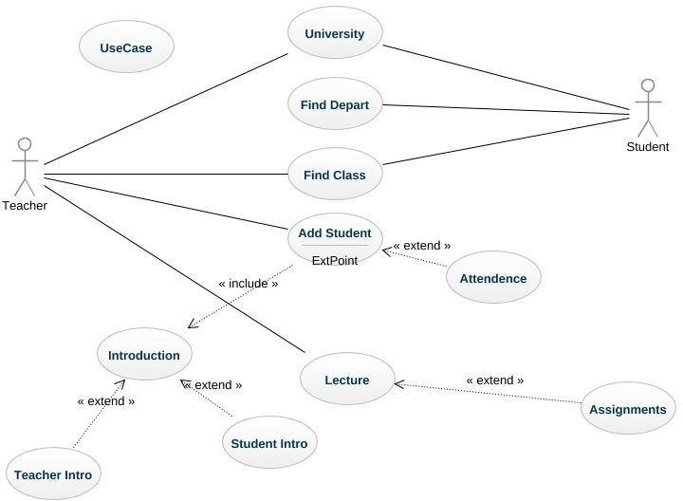

# Classes / Objects

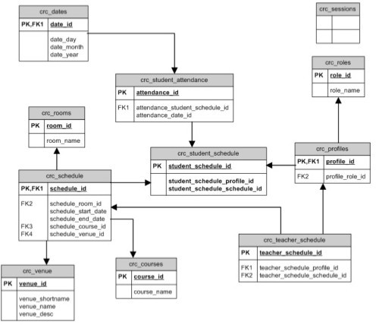

# Non-Functional Requirements

### Performance

Easy tracking of records and updating can be done. All the requirements relating to performance characteristics of the system are specified in the section below. There are two types of requirements.

1. **Static Requirements**

These requirements do not impose any constraints on the execution characteristics of the system. They are:

* 1. **Number of Terminals :**

The software makes use of an underlying database that will reside at the server, while the front end will be available online to the administrative and departmental computers as well as students and teachers.

* 1. **Number of Users :**

The number of users may vary, as this software finds applications in almost all department of the organization.

1. **Dynamic Requirements**

These specify constraints on the execution characteristics of the system. They typically include response time and throughout of the system. Since these factors are not applicable to the proposed software, it will suffice if the response tine is high and the transactions are carried out precisely and quickly.

### Reliability

The software will not be able to connect to the centralized database in the event that the college LAN fails or in the event of the server being down due to a hardware or software failure.

### Availability

The software will be available only to authorized users of the colleges like teachers to mark the students attendance, student to view their enrolled course, admin to add an update students records

### Security

The security requirements deal with the primary security. The software should be handled only by the administrator and authorized users. Only the administrator has right to assign permission like creating new accounts and generating password. Only authorized users can access the system with username and password.

### Maintainability

Backups for database are available.

### Portability

The Software is a web-based application and is built in PHP and MYSQL so it is platform independent and is independent of operating system.

## Design Constraints

This software provides security. The login form prevents the system from being misused by unauthorized users. Only an authorized operator will be granted rights to modify as per requirements. This software is also reliable and fault tolerant. The system developed is designed to handle invalid inputs. Since reliability is major area of concern the system has a backup to avoid data loss. The user should know the programming language very well that is used to develop a software.

# Other Requirements

**Database :** All the data will be stored in a relational database.

# 

# Project Timeline

|  |  |
| --- | --- |
| **Milestone** | **Time** |
| Analysis | 3 days |
| Requirements Collection | 7 days |
| Development | 30 days |
| Testing | 10 days |
| Deployment | 5 days |
| Delivery | 5 days |

# Pricing and Payment

The entire fees will be Seventy Thousand taka(70000) only

## Installation System

25% (25%)

Paid on acceptance of this proposal.

30% (55%)

Paid on signing of our Application development agreement.

30% (85%)

Paid at 70% Application Demonstration.

15% (100%)

Paid at completion the Application.

# Appendices

## Appendix : Glossary

Following abbreviations have been used throughout this document:

**DFD** : Data Flow Diagram

**ERD** : Entity Relationship Diagram

**SRS** : Software Requirement Specification

**SQL** : Structured Query Language

**SMS** : Student Management System

**STD :** State Transition Diagram

# Reference:

<https://www.wikipedia.org/>

<https://www.geeksforgeeks.org/>